Discrete Probability Distributions

In our last section, we saw that we can estimate the probability of an event by conducting or observing an experiment a large number of times, and then finding the relative frequency of the event. For instance, we can estimate the probability of rolling a 3 on a fair 6-sided die by rolling (or simulating rolling) a die many times, and finding the proportion of times a 3 is rolled.

In this section, we explore the connection between relative frequency and probability further by way of probability distributions. This will have us revisiting some of the concepts we introduced in our section on descriptive statistics, such as measures of centre and measures of variation.

First, we need some new terminology:

A random variable is any function that assigns a numerical value to each possible outcome of an experiment.

Example:

Experiment: selecting a 9V battery
X₁ = lifetime (in hours) of a 9V battery in continuous use.

Experiment: selecting 6 BCIT CST grads
X₂ = number of CST graduates who know how to construct a linked list among 6 randomly selected BCIT CST graduates.

A discrete random variable has either a finite number of values or a countable number of values.

A continuous random variable has infinitely many values, and those values can be associated with measurements on a continuous scale in such a way that there are not gaps or interruptions.

X₂ is discrete ← Counted
X₁ is continuous ← Measured

A probability distribution gives the probability of each value of the random variable.

Example:
Probability distribution of the number of BCIT CST graduates who know how to construct a linked list among 6 randomly selected BCIT CST graduates.

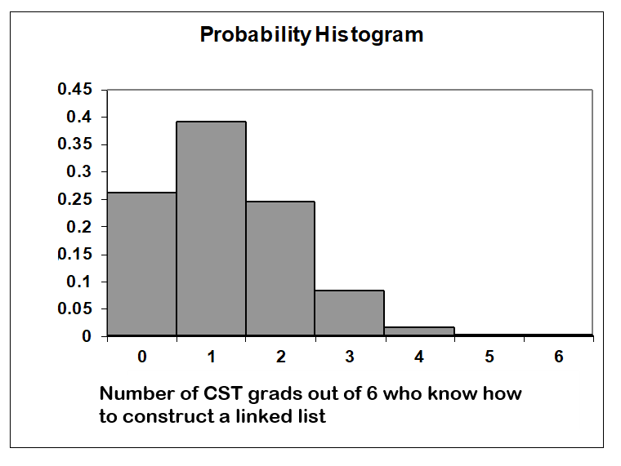
x P(x)
0 0.262
1 0.393
2 0.246
3 0.082
- 0.015
- 0.002
- 0+

Requirements for a discrete probability distribution:

1.) Σ P(x) = 1 Where x assumes all possible values

2.) 0 ≤ P(x) ≤ 1 for every value of x

Mean & Variance of a Probability Distribution:

μ = Σ[xP(x)] Also called the expected value
“What is the mean value of X”
is equivalent to
“What do we expect the value of X
to be?”

Compare this to the approximate mean for grouped data, which we saw in the unit on descriptive statistics:

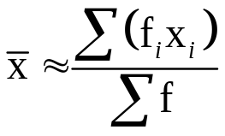

X_{i} = class mark
= mid-point of the classes
= mean of the upper and
lower class limit of a class

f_{i} = frequency
σ² = Σ[x²P(x)] - μ² Computation Formula for Variance
= Σ[(x - μ)² P(x)] Theoretical Formula for Variance

Note: The standard deviation is simply the square root of the variance.
For the BCIT CST graduates example we have:

X P(X) XP(X) X² X²P(X)
0 0.262 0.000 0 0.000
1 0.339 0.393 1 0.393
2 0.246 0.492 4 0.984
3 0.082 0.246 9 0.738
4 0.015 0.060 16 0.240
5 0.002 0.010 25 0.050
6 0+ 0.000 36 0.000
Total 1.000 1.201 2.405

μ = 1.2 BCIT CST Grads (1.201)
σ² = 2.405 – 1.201² = 1.0 (BCIT CST Grads)² (0.963)
σ = 1.0 BCIT CST Grads (0.981)

In a group of 6 BCIT CST grads, and average of will know how to construct a linked list.

Knowing μ and σ allows us to estimate the maximum and minimum values of X. It also can help us to determine which values are unusual (ie greater that 2σ above the mean or less than 2σ below the mean.)

Example:
If 6 BCIT CST grads are randomly selected, is it unusual to find 3 who know how to construct linked lists?
Expected Value (Example)

When the dealer is showing an ace in blackjack the players are offered the chance to make a side bet called insurance. The players can wager up to half of their bet that the dealer has blackjack. If the dealer has blackjack (which consists of an ace, and one of the following: ten, jack, queen, king), they are paid 2:1 on their side bet but lose their hand.

Suppose you have a 4 and a 2, and the dealer is showing an ace. What is your expected “profit” on a $5 insurance bet in single deck black jack?

Outcome | X =profit | Probability
Win (Dealer has blackjack) | 10
Lose | -5

Suppose you have a Three and a Four and you see the cards of the player next to you and he has a Five and a Seven. As before, the dealer is showing an ace.

Outcome | X =profit | Probability
Win (Dealer has blackjack) | 10
Lose | -5

When an experiment meets certain conditions, we are often able to compute probabilities using formulas. We introduce some such experiments here.
The Binomial Distribution

Binomial situations arise as the name implies when there are two possible outcomes to a given experiment.

Win/Lose
Live/Die
True/False
Succeed/Fail
Within Tolerance/Not Within Tolerance

Features of binomial experiments (aka Bernoulli Trials)

- The experiment consists of a fixed number, n, of identical trials (or repetitions of some operation or observation).

- Each trial results in one of the same two possible outcomes, which are conventionally denoted by the characters S (for "success") or F (for "failure").

- The successive trials are independent in the sense that the outcome in one trial doesn't influence the outcome in the next or any of the other trials in the experiment.

- The probability of S is the same in each trial, and is conventionally denoted by the letter 'p'. We denote the complementary probability 1 - p of the outcome F in each trial with the letter 'q'.

Note:
If you are interested in the probability of a person dying during a given month, you would consider a death a success under our assumptions above.

CAUTION: we need to verify that all of the conditions of the binomial distribution are satisfied before we apply our formulas.

Example:
Rolling a fair die 5 times and counting the number of 3’s obtained is an example of a binomial experiment.

Verifying that each condition is met:

We will now try to find a formula for the probability of obtaining k success in n identical trials, each with probability p of success. We do this by investigating the above die-rolling example in detail.

Die rolling: an experiment

A six sided die is rolled 5 times. Let the random variable X denote the number of 3’s. We’re interested in the probability distribution of X.

- List all of the possible outcomes of the five die roll, but consider all non 3’s as equivalent. So we can consider the roll 1-2-3-4-5 to be equivalent to the roll 4-2-3-6-6, and list them each as xx3xx. It may be helpful to list the outcomes in some systematic order so as to avoid omitting or repeating any.
Recall that P(k) denotes the probability of rolling k 3’s.
- What is the probability of rolling no 3’s?
P(0) =
- What is the probability of rolling all 3’s?
P( ) =
- What is the probability of rolling exactly one 3?

- What is the probability of rolling exactly two 3’s?
- What is the probability of rolling exactly three 3’s?
- What is the probability of rolling exactly four 3’s?
In general, the probability of obtaining k 3’s is:

Binomial Probability distribution

In a binomial experiment, we can find the probability of x successes in n independent trials using the following formula:

P(x successes in n trials) = 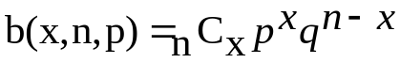

Where p is the probability of a success and q = 1 - p is the probability of a failure.

Recall: 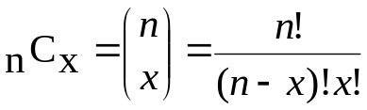

Example:
If 5 cards are selected with replacement from a deck, find the probability that 2 are jacks.

Example:
If 5 cards are selected with replacement from a deck, find the probability that at least 2 are jacks.

Mean and Variance For Binomial Distributions

Recall that the mean and variance of any probability distribution may be found using the following formulae.

μ = Σ[xP(x)] Also called the expected value

σ² = Σ[x²P(x)] - μ² Computation Formula for Variance
= Σ[(x - μ)² P(x)] Theoretical Formula for Variance

It can be shown that for binomial distributions that these formulae simplify nicely. The value for μ is fairly intuitive:

For instance, consider an experiment that consists of rolling a regular die 60 times. We will define a success as rolling a 3. The mean, or expected value, of this probability distribution is the number of times we expect to roll a 3.

In this case, μ =
In general, in a binomial experiment with n trials and a probability p of success,

μ =

Standard deviation is a little less intuitive, but we can show that
σ² = npq where q = 1 - p

Being able to calculate μ and σ allows us to consider Chebyshev's Theorem and the Empirical rule.

Example (Empirical Rule)

The probability of a particular brand of laser printer needing repairs in the first year is 10%. Modifications were made to the printer design and a year later a study of 200 randomly selected modified laser printers was conducted.

- Assuming the modification had no effect, find the mean and standard deviation of the number of laser printers that need repair among 200.

- Among the 200 laser printers, 14 needed repair. If the modifications had no effect, is this rate unusually low?
Recall that we consider a value to be unusual if…

The Hypergeometric Distribution

The hypergeometric distribution is similar to the binomial distribution with the exception that trials are not necessarily independent.

In lab, we saw that sampling without replacement is fairly similar to sampling with replacement, provided the sample size is small. The general guideline is that sampling without replacement can be modeled fairly accurately by a binomial distribution if the sample size is less than 5% of the population. When the sample size is greater, we use the hypergeometric distribution instead.

Example:
If 5 cards are selected without replacement from a deck, find the probability that 2 are jacks.

Compare to the answer we obtained when we selected 5 cards with replacement:

Hypergeometric Distribution

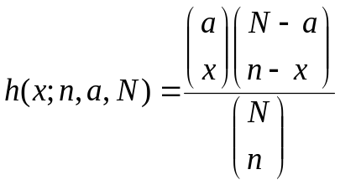 for x = 0, 1, 2, …, n

This is the probability of x successes in a group of n objects selected from a set of N objects where a of the N objects are known to be successes.
μ = 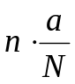

σ² = 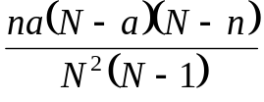

Example:
If 6 of 18 new buildings in a city violate the building code, what is the probability that a building inspector, who randomly selects 4 of the new buildings to inspect will catch at least 1 of the new buildings in violation of the code.

Example:
With regard to the new buildings example, where 6 of 18 new buildings are in violation of building codes, find the mean and standard deviation of the probability distribution of the number of buildings in violation in a sample of 4 randomly selected for inspection. Would it be unusual to find NO buildings in violation?

The Geometric Distribution

The Geometric Distribution is similar to the binomial distribution, except that the number of trials is not fixed and the random variable X is given the value of the trial on which the first success occurs.

Example:
Suppose a tech-support help line is occupied 75% of the time. Compute the probability that you will have to dial 5 times to gain access?

Solution:

g(x; p) = p (1-p)^{x-1} where x = 1, 2, 3, 4, …

μ = 1/p

σ² = (1-p)/p²

Example:
Suppose a tech-support help line is occupied 75% of the time. Compute the probability that you will have to dial 5 or more times to gain access?

Solution:

Example (continued):
Find the expected number of attempts needed to reach an operator.

The Poisson Distribution

The Poisson Distribution is one of the most important probability distributions in engineering and computer science.

Consider an experiment in which an observer is counting the number of happenings in an interval of time or space.

Examples:
- Number of jobs arriving for service at a CPU per second.
- Number of shoppers arriving at a check-out counter per minute.
- Number of units being rejected at a quality control station per hour.
- Number of bits in arriving in error at a network node per minute.
Etc.

The Poisson Distribution is a discrete probability distribution that applies to occurrences of some event over a specified interval. The random variable X is the number of occurrences of the event in an interval. The interval can be time, distance, area, volume, or some similar unit.

The probability of an event occurring x times over an interval is given by:

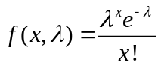 where e ≈ 2.71828

Requirements for a Poisson Distribution:
- The random variable X is the number of occurrences of an event over some interval.

- The occurrences must be random.

- The occurrences must be independent of each other.

- The occurrences must be uniformly distributed of the interval being used. (i.e. an occurrence must be equally likely to occur during the interval.)

Mean and Standard Deviation of a Poisson Distribution

Mean = λ

Standard Deviation = 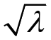

Differences between the Poisson and Binomial distributions.

- The binomial distribution is affected by the sample size n and the probability p, whereas the Poisson distribution is affected only by the mean μ (λ).

- In the binomial distribution, the possible values of the random variable X are 0, 1, …, n, but a Poisson distribution has possible X values of 0, 1, 2, … with no upper limit.

Example:

In an interactive time-sharing environment it is found that, on average, a job arrives for CPU service every 6 seconds. Assuming the arrivals satisfy the Poisson conditions, what is the probability that there will be 3 arrivals in a given minute?

Solution:

Example:

In an interactive time-sharing environment it is found that, on average, a job arrives for CPU service every 6 seconds. Assuming the arrivals satisfy the Poisson conditions, what is the probability that there will be 3 or fewer arrivals in a given minute?

Solution:

